MOOC 4-MODULE 2
Unsupervised Machine Learning

I.Distance Metrics: Euclidean and Manhattan Distance
Distance Metrics Overview
- Different distance metrics, such as Euclidean distance, Manhattan distance, Cosine similarity, and Jaccard distance, are essential for clustering algorithms.
- The choice of distance metric significantly impacts the performance and results of clustering algorithms.
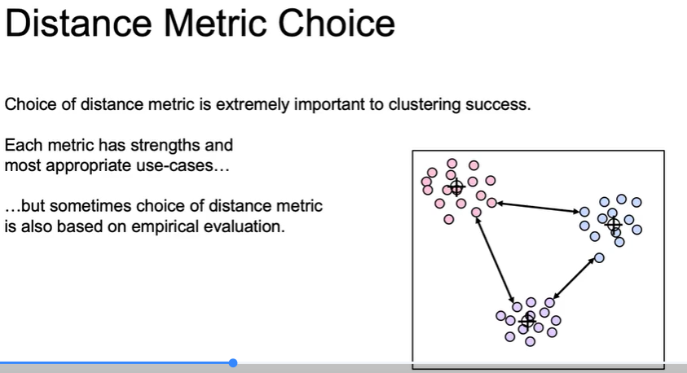
Euclidean and Manhattan Distances
- Euclidean distance (L2 distance) is the most intuitive and commonly used metric, calculated using the square root of the sum of squared differences.
- Manhattan distance (L1 distance) sums the absolute differences and is more effective in high-dimensional spaces, where distinguishing distances can be challenging.
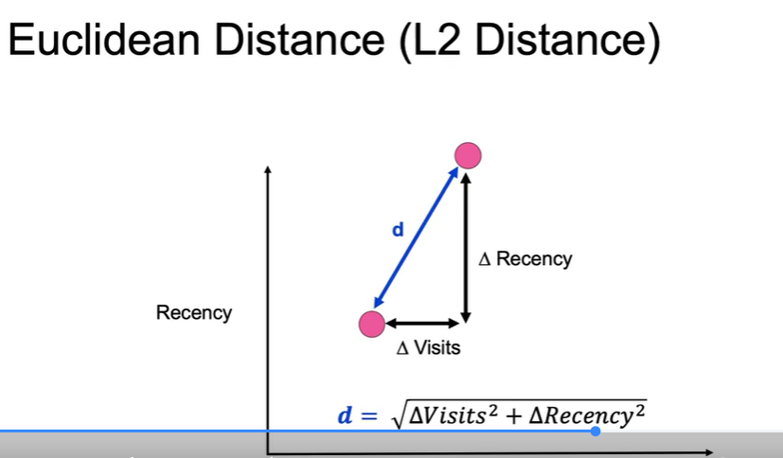
Future Exploration
- The next video will introduce less common but powerful distance metrics that can be beneficial for specific applications in clustering.
II.Distance Metrics: Cosine and Jaccard Distance
cosine distance
- Cosine distance measures the angle between two points in space, emphasizing the direction rather than the magnitude.
- It remains insensitive to scaling, meaning points along the same ray from the origin will have a distance of 0, making it useful for comparing relationships in data like text documents.
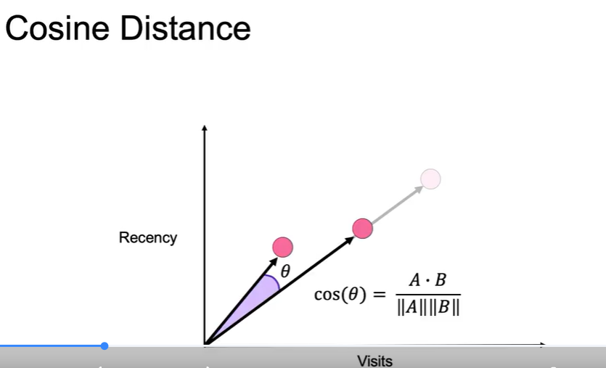
Jaccard distance
- Jaccard distance is used for comparing sets, calculated as 1 minus the ratio of the intersection of two sets to their union.
- It is particularly useful for text data, allowing for the grouping of similar topics based on unique word occurrences.
